# Holocaust Survivor Day 2024 Promotional Toolkit

## Everything you need to promote your events on Holocaust Survivor Day.

**Holocaust Survivor Day is a day to celebrate the bravery, sacrifices, and lives of survivors.**

We believe that Holocaust Survivors are our teachers, but the responsibility of passing on the legacy of their testimonies lies with all of us.

On **June 4th, 2024,** organizations from around the world will come together to celebrate survivors. Each organization and community will hold their own events locally, but together, we will celebrate those who survived.

**You can learn more and sign up as a partner by visiting** [**our website.**](https://www.holocaustsurvivorday.com/)

## General Brand



Find the style guide and download links, [here.](https://drive.google.com/open?id=1oFTOlAFnel0dq1gQIeFjjfBxxHIz3cA4&usp=drive_fs)  
Find curated and usable photos, [here](https://drive.google.com/open?id=1WxWi8tcTp9FovYlYuATWq_2FXZq2HK5r&authuser=jfnacreativeteam%40gmail.com&usp=drive_fs).

## Social Posts

We have created social media assets for posts and stories across various platforms. Use #HolocaustSurvivorDay in your posts!

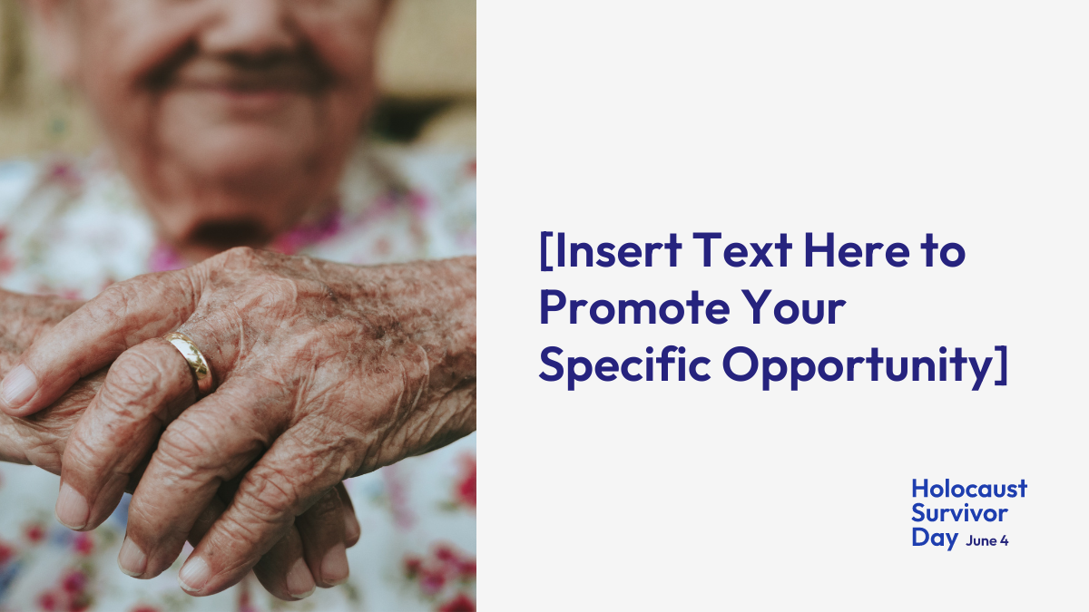

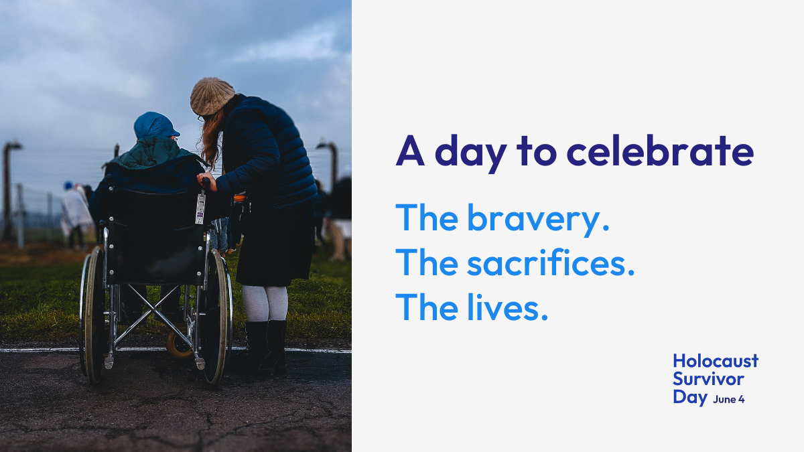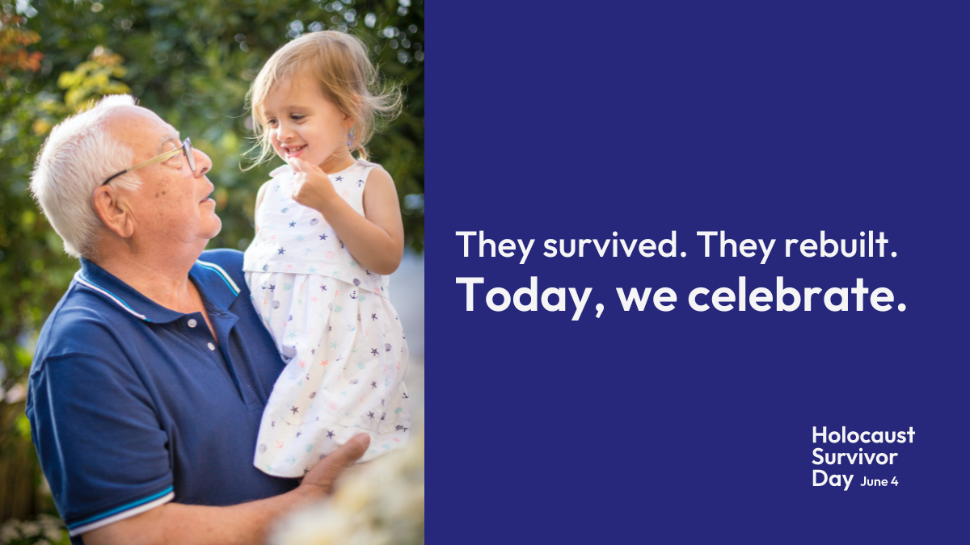

Download the post [here](https://dl.orangedox.com/8dHXwSK2DTJ2fkJKhI)To customize these posts for your own efforts, use these templates:

[Story size](https://www.canva.com/design/DAGEmuRnONY/Z77k_RRhflCmASCrH_3Tmg/view?utm_content=DAGEmuRnONY&utm_campaign=designshare&utm_medium=link&utm_source=publishsharelink&mode=preview) | [Twitter(X)/Facebook size](https://www.canva.com/design/DAGEmvb0xWk/LnNowKjmQ_K8IP4UTva7tg/view?utm_content=DAGEmvb0xWk&utm_campaign=designshare&utm_medium=link&utm_source=publishsharelink&mode=preview) | [Instagram size](https://www.canva.com/design/DAGEmqXPpgA/-XtyUy60d5KqPd70OmjI2A/view?utm_content=DAGEmqXPpgA&utm_campaign=designshare&utm_medium=link&utm_source=publishsharelink&mode=preview)

## Web Banners



Download the post [here](https://dl.orangedox.com/8dHXwSK2DTJ2fkJKhI)To customize these banners for your own efforts, use these templates.

[Large(1040x596px)](https://www.canva.com/design/DAGEmtsh5Nw/EX7Ja-GJZ4-sVWchxKD6Rg/view?utm_content=DAGEmtsh5Nw&utm_campaign=designshare&utm_medium=link&utm_source=publishsharelink&mode=preview) | [Small(600x200px)](https://www.canva.com/design/DAGEmirOa00/Jj1UYK7bJvkniouCl_UGFw/view?utm_content=DAGEmirOa00&utm_campaign=designshare&utm_medium=link&utm_source=publishsharelink&mode=preview)